Exercise 7 (Word Document)
When two fair six-sided dice are rolled, each die is equally likely to show any number from 1 to 6. The sum can range from 2 to 12.
- Create a discrete probability table for the sum of two dice.
- Calculate each possible outcome (sum) and the number of ways to obtain it.
- Calculate the probability of each sum (use total outcomes = 36).

Sum(X) | Possible outcomes | Probability P(X=x)
2 | (1,1) | 1/36 = 0.02777778
3 | (1,2), (2,1) | 2/36 = 0.05555556
4 | (1,3), (2,2), (3,1) | 3/36 = 0.08333333
5 | (1,4), (2,3), (3,2), (4,1) | 4/36 = 0.11111111
6 | (1,5), (2,4), (3,3), (4,2), (5,1) | 5/36 = 0.13888889
7 | (1,6), (2,5), (3,4), (4,3), (5,2), (6,1) | 6/36 = 0.16666667
8 | (2,6), (3,5), (4,4), (5,3), (6,2) | 5/36 = 0.13888889
9 | (3,6), (4,5), (5,4), (6,3) | 4/36 = 0.11111111
10 | (4,6), (5,5), (6,4) | 3/36 = 0.08333333
11 | (5,6), (6,5) | 2/36 = 0.05555556
12 | (6,6) | 1/36 = 0.02777778

- Identify the most likely sum and explain why in 1–3 sentences.
The most likely sum is 7, with a probability of 6/36 = 0.166666667(16%). The sum of 7 is most likely because it can be made in the largest number of ways i.e it has 6 different combinations: (1,6), (2,5), (3,4), (4,3), (5,2), (6,1). Other sums have fewer possible combinations, so they are less likely to occur.

- Compute P(sum≥9).
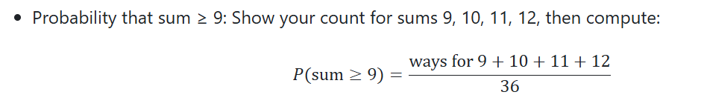
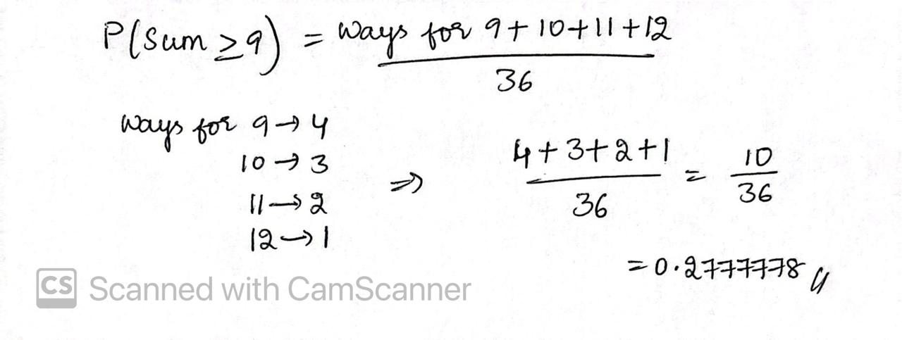
There is about a 27.8% chance that the sum of two dice will be 9 or greater.

- Calculate the expected value of the sum of two rolled dice. Show the calculations.

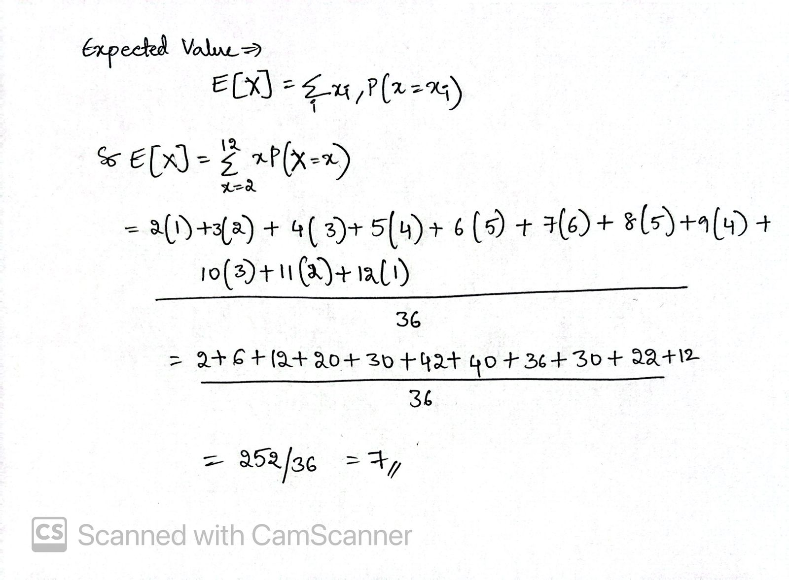
The expected value of the sum of two dice is 7.

